Titration
A lab process in which a known concentration of an acid or base is used to determine the unknown concentration of another acid or base solution.

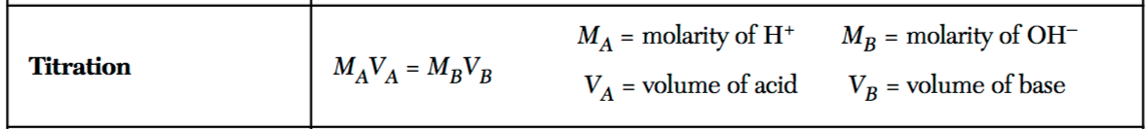
sometimes this equation is written as
(#H⁺)M_{A}V_{A} = (#OH⁻) M_{B}V_{B}

When 50 ml of an HNO₃ solution is exactly neutralized by 150 ml of a 0.5M solution of KOH, what is the concentration of HNO₃?
M_{a}= ? M_{B}=0.5M
V_{a}=50ml V_{B}=150ml

M_{a}(50ml) = (0.5M)(150 ml)
M_{a}=1.5M

