Solutions Review
Homogenous mixture: also called aqueous, also called a solution. Evenly distributed.
NaCl (aq): NaCl is dissolved in water
Heterogeneous mixture: unevenly distributed. Ex. Sand in water
Separation of mixtures
Distillation: separation of 2 liquids by boiling point Chromatography: separation by density and polarity
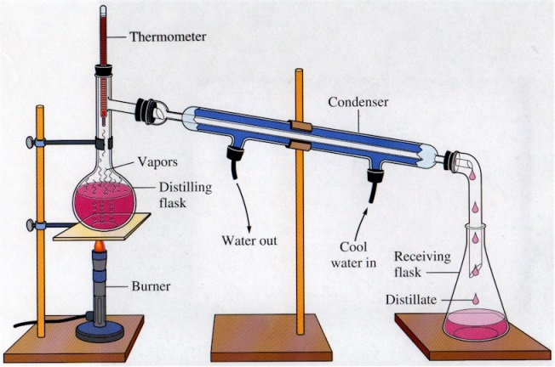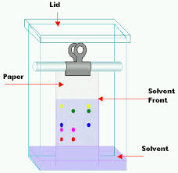
Filtration: separating a solid from a liquid (heterogeneous mixture)
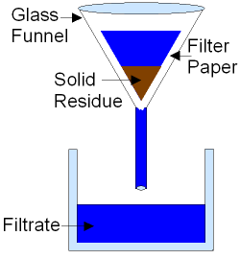
Evaporation: separating a dissolved solid from the liquid (homogenous mixture)
Polar vs. Non polar molecules:
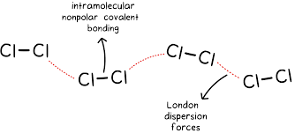
Like dissolves like. Water is polar and will dissolve other polar substances, Non polar substances do not dissolve in water (ex oil)
Double replacement reactions:
Predicting products
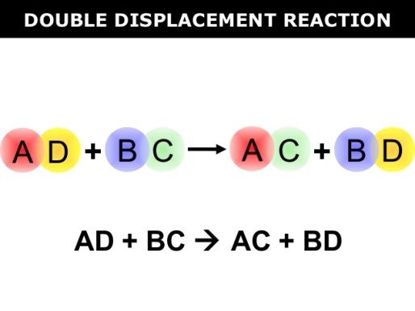

3 LiOH + Fe(NO₃)₃ → Fe(OH) ₃+ 3 Li(NO₃)

Fe(OH)₃ would form a precipitate based on table F

AgF + Na₂CO₃ →

Precipitate: ______________

NaOH + H₃PO₄ →

Precipitate: ______________

Ba(CN)₂ + (NH₄)₂SO₄ →

Precipitate: ______________

