Name____________________________ Date ___________________ Class _____________

***Solutions Constructed Response Review Questions***

6. Four flasks each contain 100 milliliters of aqueous solutions of equal concentrations at 25°C and 1 atm.

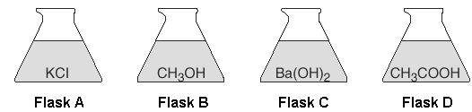

Which flask has the solution with the *lowest* freezing point? Explain your answer.

______________________________________________________________________________

______________________________________________________________________________

______________________________________________________________________________

______________________________________________________________________________

7. The equation for the saturated solution equilibrium of potassium nitrate (KNO3 ) is shown below.

chem080260

Compare the rate of dissolving KNO3 with the rate of recrystallization of KNO3 for the saturated solution.

______________________________________________________________________________

______________________________________________________________________________

8. At equilibrium, nitrogen, hydrogen, and ammonia gases form a mixture in a sealed container. The data table below gives some characteristics of these substances.

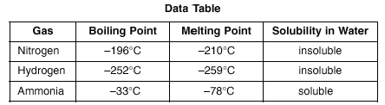

Describe how to separate ammonia from hydrogen and nitrogen.

______________________________________________________________________________

______________________________________________________________________________

______________________________________________________________________________

8. When cola, a type of soda pop, is manufactured, CO2 (g) is dissolved in it.

a. A capped bottle of cola contains CO2 (g) under high pressure. When the cap is removed, how does pressure affect the solubility of the dissolved CO2 (g)?

______________________________________________________________________________

______________________________________________________________________________

b. A glass of cold cola is left to stand 5 minutes at room temperature. How does temperature affect the solubility of the CO2 (g)?

______________________________________________________________________________

______________________________________________________________________________

1. Given the equation for the dissolving of sodium chloride in water:

cr52-1

Explain, in terms of *particles*,why NaCl(*s*) does *not* conduct electricity.

10. A student uses 200 grams of water at a temperature of 60°C to prepare a saturated solution of potassium chloride, KCl.

Identify the solute in this solution. ___________________________________________________

11. A student uses 200 grams of water at a temperature of 60°C to prepare a saturated solution of potassium chloride, KCl. This solution is cooled to 10°C and the excess KCl precipitates (settles out). The resulting solution is saturated at 10°C. How many grams of KCl precipitated out of the original solution?

12. Calcium hydroxide is commonly known as agricultural lime and is used to adjust the soil pH. Before the lime was added to a field, the soil pH was 5. After the lime was added, the soil underwent a 100-fold decrease in hydronium ion concentration.

According to Reference Table *F*, calcium hydroxide is soluble in water. Identify another hydroxide compound that contains a Group 2 element and is also soluble in water. ________________________

13. Naphthalene, a nonpolar substance that sublimes at room temperature, can be used to protect wool clothing from being eaten by moths. Explain why naphthalene is *not* expected to dissolve in water

______________________________________________________________________________

______________________________________________________________________________

14. Base your answer to the question on the table below.

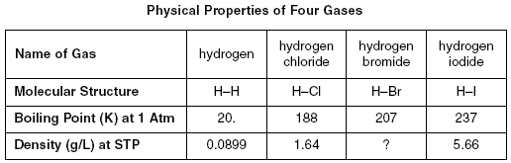

Explain, in terms of molecular polarity, why hydrogen chloride is more soluble than hydrogen in water under the same conditions of temperature and pressure.

______________________________________________________________________________

______________________________________________________________________________

______________________________________________________________________________

15. Acid rain lowers the pH in ponds and lakes and over time can cause the death of some aquatic life. Acid rain is caused in large part by the burning of fossil fuels in power plants and by gasoline-powered vehicles. The acids commonly associated with acid rain are sulfurous acid, sulfuric acid, and nitric acid.

In general, fish can tolerate a pH range between 5 and 9. However, even small changes in pH can significantly affect the solubility and toxicity of common pollutants. Increased concentrations of these pollutants can adversely affect the behavior and normal life processes of fish and cause deformity, lower egg production, and less egg hatching.

Sulfur dioxide, SO2, is one of the gases that reacts with water to produce acid rain. According to Reference Table *G*, describe how the solubility of sulfur dioxide in water is affected by an increase in water temperature.

______________________________________________________________________________

______________________________________________________________________________

16. Given the balanced equation for dissolving NH4Cl(s) in water:

cr148

A student is holding a test tube containing 5.0 milliliters of water. When a sample of NH4Cl(s) is placed in the test tube, the test tube feels colder to the student’s hand. Describe the direction of heat flow between the test tube and the hand.

______________________________________________________________________________

______________________________________________________________________________

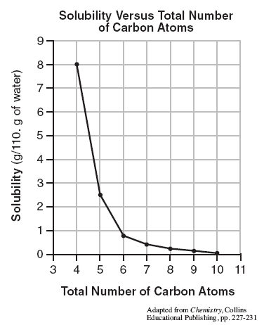17. The graph shows the relationship between the solubility of a sequence of primary alcohols in water and the total number of carbon atoms in a molecule of the corresponding alcohol at the same temperature and pressure. A primary alcohol has the -OH group located on an end carbon of the hydrocarbon chain.

Describe the relationship between the solubility of a primary alcohol in water and the total number of carbon atoms in the primary alcohol.

_______________________________________________________________

____________________________________________________

________________________________________________________________

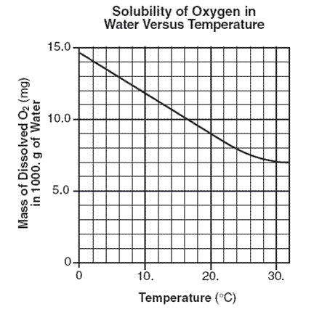18. Scientists who study aquatic ecosystems are often interested in the concentration of dissolved oxygen in water. Oxygen, O2, has a very low solubility in water, and therefore its solubility is usually expressed in units of milligrams per 1000. grams of water at 1.0 atmosphere. The graph below shows a solubility curve of oxygen in water.

a. A student determines that 8.2 milligrams of oxygen is dissolved in a 1000.-gram sample of water at 15°C and 1.0 atmosphere. In terms of saturation, what type of solution is this sample?

________________________________________________

b. Explain, in terms of molecular polarity, why oxygen gas has low solubility in water. Your response must include both oxygen and water.

______________________________________________________

______________________________________________________

______________________________________________________________________________

_____________________________________________________________________________

Key

Water

K+

NO3-

1. Potassium Nitrate dissolves in water as follows: KNO3(s) + H2O(l) 🡪 K+(aq) + NO3- (aq)

+

In the box to the far right, diagram the products using the key provided.

-

Indicate the exact arrangement of the particles

as you diagram. You will need to use multiple water