**Energy and Gases**

1. Energy
   1. Types of Energy
      1. Thermal=heat
      2. Kinetic= energy of motion (directly proportional to temperature)
      3. Potential = Stored
   2. Transfer of Energy
      1. Heat moves from high to low temperature
2. Heating and Cooling curves
   1. Heating curves_ endothermic phase changes
   2. Sublimation- solid to gas
   3. Kinetic changes on curves potential changes on flat parts

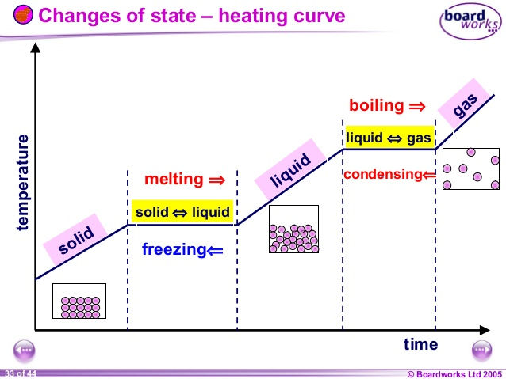

* 1. Cooling curves Exothermic phase changes
  2. Deposition- gas to solid

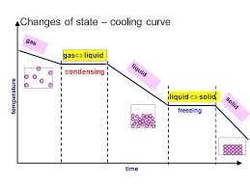

Heat Calculations

* 1. q=mc∆T- temperature is changing or 2 different temperatures.

∆T=final - initial

* 1. q=mHf- freezing or melting
  2. q=mHv- boiling or condensing or vaporizing
  3. Heat added at a constant rate is rate X time on the graph

1. Gases
   1. Kinetic Molecular Theory of Gases
      1. Random Straight line motion



* + 1. No attraction



* + 1. No volume



* + 1. No loss of energy in collision. Transfer of energy
    2. Real gases behave ideal under high temperature and low pressure
    3. H2 and He are closest to ideal
  1. Vapor Pressure curves Table H
     1. High boiling point high intermolecular forces
     2. High vapor pressure=lower intermolecular forces
     3. Boiling is the point where vapor pressure equals atmospheric pressure of that liquid
  2. Combined Gas law
     1. PV = PV  
        T T
     2. Boyles Law



PV=PV



* + 1. Charles Law



* 1. Avogadros Hypothesis: Equal volumes of gas at the same temperature and pressure have equal number of particles.



1. Honors topics



* 1. Triple point diagram



* 1. Multi step heating and cooling problems



* 1. Ideal gas law



* 1. Gas density using Avogadros hypothesis
  2. Manometers