Chemistry Facts Sheets
Matter and Energy
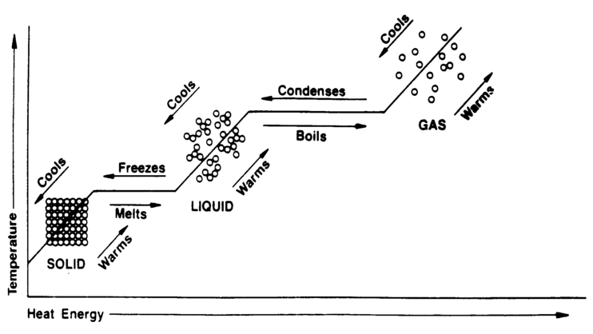
Heat flows from high to low temperature.
Heat = Kinetic Energy ie. Highest temperature = highest kinetic energy
Part 2 questions:
In terms of energy or particle behavior…… answer energy either increases or decreases or kinetic or potential energy increase or decrease. Never both at the same time.
Why is the lower plateau shorter than the upper? More energy needed to vaporize than melt. Do not mention temperature.
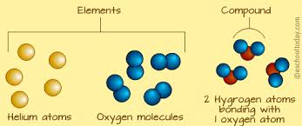
Gas Laws
Given PV =PV Temperature is ALWAYS IN KELVIN Even if they give you celcius CONVERT IT
T T K = C + 273
BOYLES LAW | CHARLES LAW
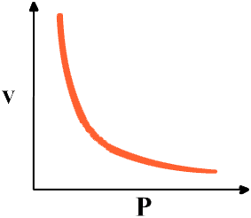  INDIRECT | 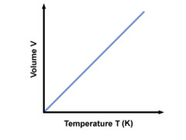  DIRECT

Atomic Structure
Carbon-14 = C-14 = ¹⁴C = ¹⁴₆C
Atomic number =protons=nuclear charge
Atom protons = electrons
Ion GIN LIPS Gain electrons is negative charge lose electrons is positive charge and smaller radus.
Ground State= off periodic table be careful that atomic number matches symbol
Carbon 2-6 is ground Excited could be 2-5-1 or 1-6-1 or 1-5-2 etc.
Excited State = one or more electrons moves up. NOT GAINED OR LOST JUST MOVES.

Spectral lines or spectra is the light produced when the excited electrons move back to ground state. Mixtures must have ALL THE LINES OF WHATEVER ELEMENTS ARE PRESENT
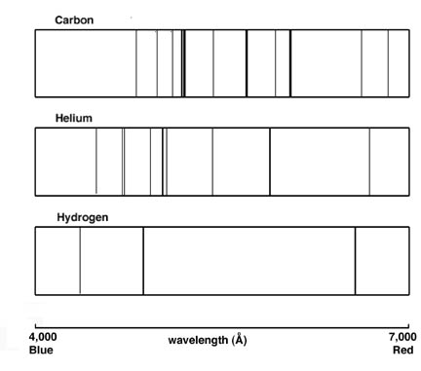
Part 2 questions:
In terms of electron transition explain where a spectra comes from? An excited electron falls from the excited energy state to ground state and gives off light.
Average atomic Mass calculation= weighted average of naturally occurring isotopes.
(percent) (mass)/100 + (percent ) ( mass)/ 100…..
In terms of subatomic particles how are Ne-21 and Ne -20 different? Isotope = different number of neutrons

Atomic Theory
Rutherford Gold foil experiment= (+) alpha particles fired at gold foil Results 1. Most went through - Atom is mostly empty space
2. A few deflected small (+) nucleus
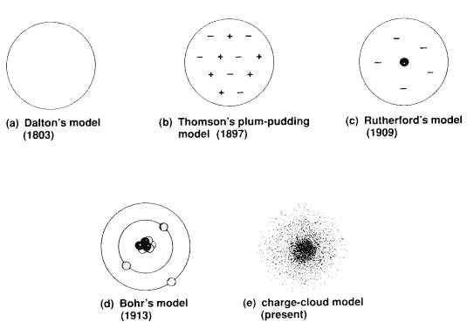

Lewis Dot
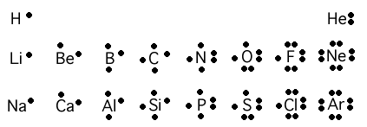
Kernal = nucleus
Ions and Ionic bonds
Na⁺ or Ca⁺² No valence electrons

Covalent  Shared electrons  Molecular  Low melting point  Weaker intermolecular force than ionic  (Hydrogen bonding is included in this category)  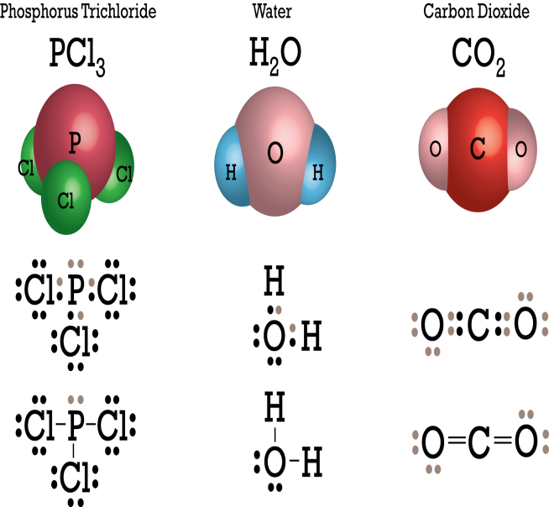 | Ionic  Transfer electrons  Crystal Lattice  High Melting point  Strong intermolecular force  Conduct in water due to mobile ions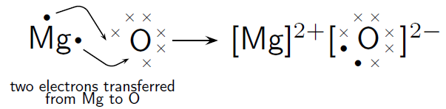 | Metallic  Ag, Pb, Cu etc.  Conduct in liquid or solid due to mobile electrons
Bonding part 2
In terms of electronegativity difference Answer: look up on table S and say who has a higher number and who has a lower number
BEND Bond ElectroNegativity Difference
In terms of intermolecular forces ….
Hydrogen Bonding : H₂O, NH₃ and HF all have the highest boiling point due to high intermolecular forces.
Van der Waals forces: Br_{2,} I_{2,} N_{2,} Cl_{2,} H_{2,} O_{2,} F₂, CO₂ and CH₄ all are non polar and have weak intermolecular forces. These forces increase as molecules get larger and closer together. Ex. Halogens have small F₂ which is a gas (weak forces), Br₂ is larger and liquid and I₂ is larger and solid (stronger forces)
All polar covalent compound have boiling points and forces in between hydrogen and Van der Waals
Why is a bond polar? One element has a higher electronegativity.
In terms of molecular polarity or polarity why does something dissolve in water?
Water is polar and will dissolve other polar substances anything non polar will not dissolve in water.
In terms of symmetry SNAP Symetrical Nonpolar Asymetrical Polar
Periodic Table
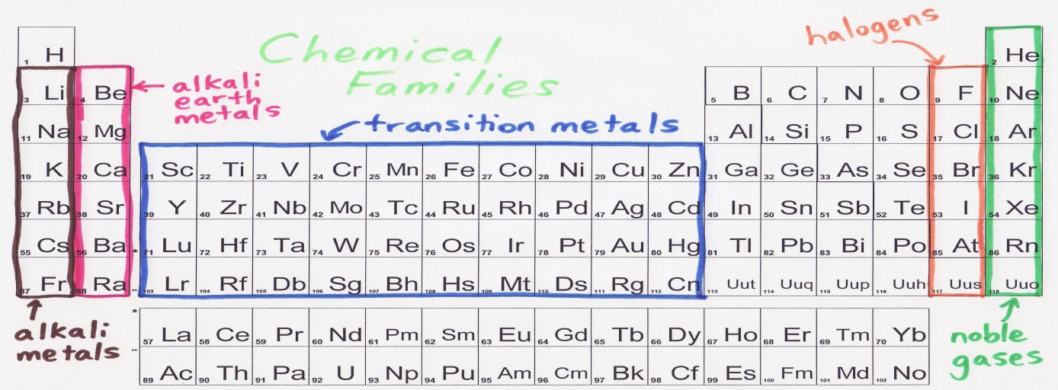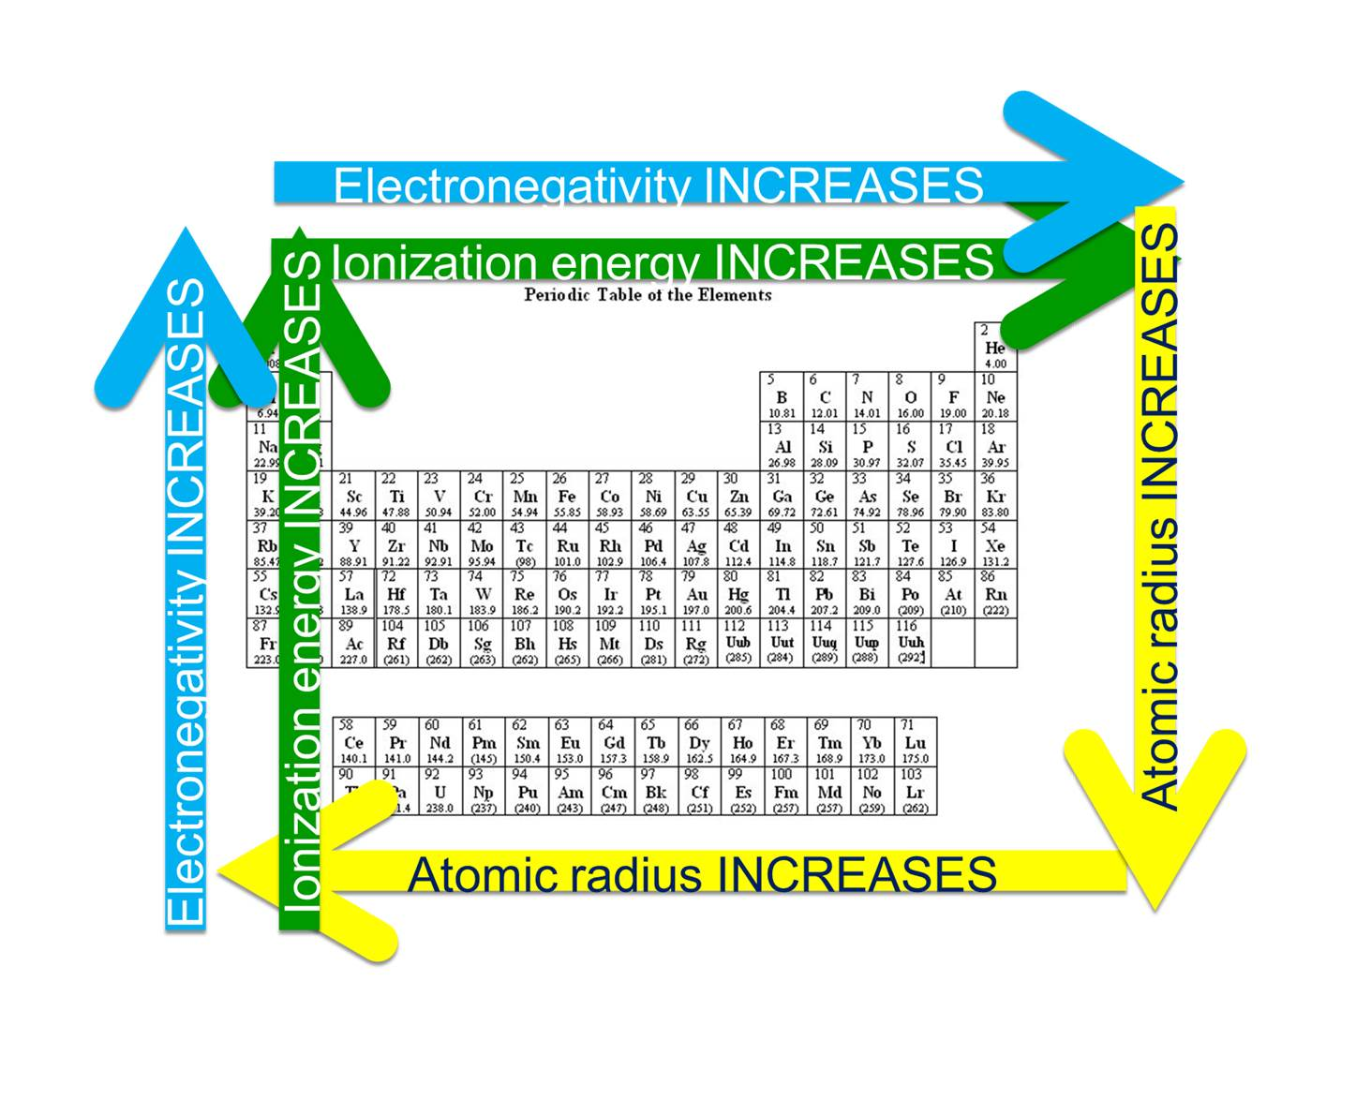
Same group = same valence electrons = similar chemical properties
Ionization energy: metals are low and lose electrons, non metals are high and keep electrons
Electronegativity: metals are low and lose electrons, non metals are high and take electrons
Atomic radius: Increase down due to more shells of electrons. Decrease across due to larger (+) nuclear pull on electrons.
Math of Chemistry
Always check table T for formula put formula and substitute numbers
Stoichiometry
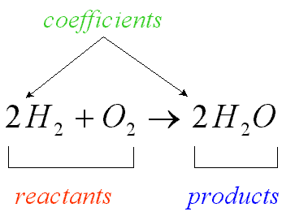

If 10 moles of H₂ are used how much oxygen is needed?

% of H in H₂O
Part/whole x 100= 2/18 x 100
If one mole of Ar occupies 26.5 l at STP what is the density of the gas?
D=M/V D= atomic mass off periodic table is one mole / 26.5

Solutions
Solubility curves Table G

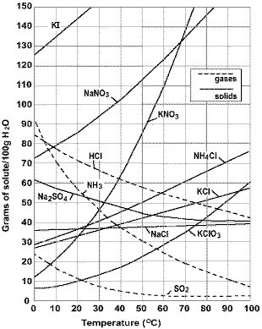
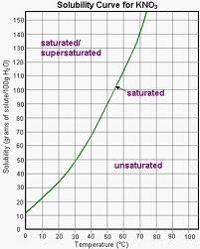
These graphs are in 100 grams of water. If they change water you need to change the amount proportionally.
When you add anything to a pure liquid it will raise the boiling point and lower the freezing point.
The more stuff added per amount of water the more the boiling and freezing point will change
The more pieces the more the boiling point and freezing point will change. Ionic breaks up covalent does not break up.
C₆H₁₂O₆ NaCl CaCl₂
1 piece littlle change 2 pieces 3 pieces highest bp lowest fp
Polyatomic ions stay together as one piece…Check table E
Ai(NO₃)₃ is 4 pieces… one Al and 3 (NO₃)

Organic Chemistry
USE TABLES P,Q AND R
Saturated=single bond=substitution reaction

Isomers: same molecular formula (number of each element) different structural formula( arrangement of elements)
Naming
Count the longest chain and name using chart P and Q
Look for side chains and name them with number of carbons and “yl”
Put number of which carbon side chain is on if it is longer than 4 carbons

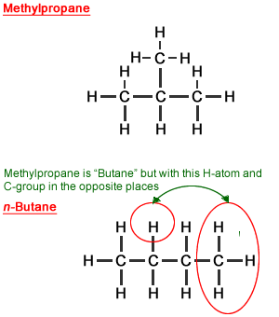

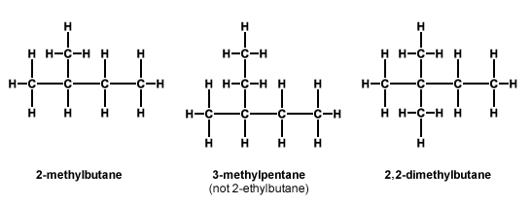

Double bond is 2 pair or 4 electrons between 2 carbons, 2 oxygens or an oxygen and carbon shared

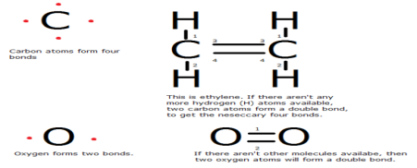

Triple bonds share 3 pair or 6 electrons between 2 carbons, carbon and nitrogen or 2 nitrogens
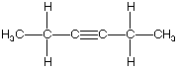

Organic reactions

Addition | 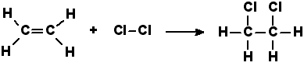
Substitution | 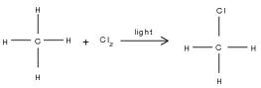
Combustion | 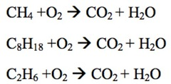
Saponification

Polymerization | 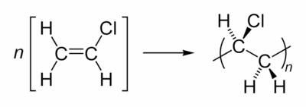
Esterification | 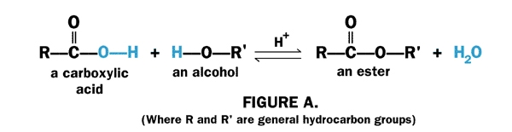
Fermentation | 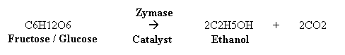

Kinetics and Equilibrium

Exothermic: heat is released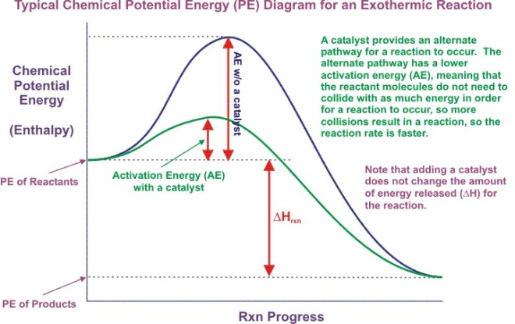
Endothermic: heat is absorbed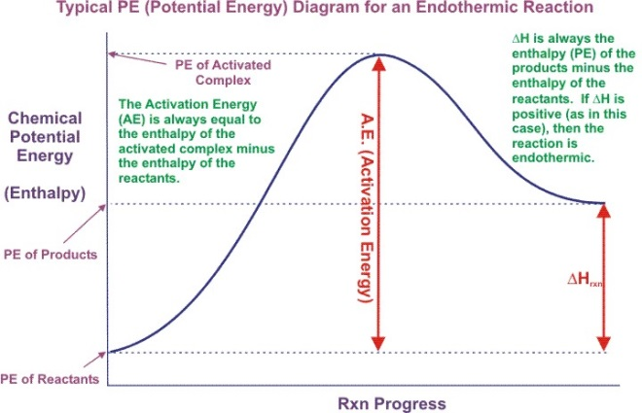
Catalyst: Lowers the activation energy, provides an alternate pathway. Speeds up reaction without being used up also called an enzyme Reaches equilibrium faster. Speeds up both directions
Table I Heats of reaction (H)
Minus is exothermic, positive is endothermic
Look at number of moles If this changes you need to do a mole ratio.
Exo is added to end( even though it is a negative number) endo is added to beginning
Le Chatalier: Add something shift the equilibrium. Add away take toward
Pressure: count moles of GAS and increases the side with the LOWER number of moles of gas
Things that Increase reaction rate:
1. Surface area,
2. Concentration (pressure for gases)
3. Catalyst,
4. Temperature

Acids and Bases
ACIDS | BASES
On table K  Start with H or end in COOH  Electrolyte: conducts in aqueous because of mobile IONS  Low pH 1-6  H+ also called hydrogen ion, hydronium ion (H₃O+) and hydrated proton. | On table L  Metal plus OH (NOT C with OH)  Electrolyte: conducts in aqueous because of mobile IONS  High pH 8-14  OH- is also called hydroxide ion

Neutralization
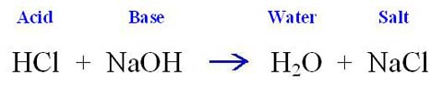
Titration: finding the volume or molarity of an unknown acid or base using the molarity and volume of a known acid or base
(# of H) M_{a}V_{a} =(#OH)M_{B}V_{B}
If given initial and final volumes must subtract to find volume used
pH
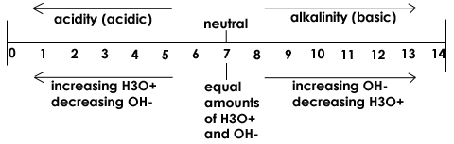
Every jump is 10X
Ph 1 pH 3 is 100X more basic or 1/100 less acidic
Nuclear Chemistry
Natural Transmutation
Artificial Transmutation | 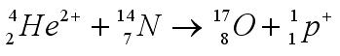
Fission | 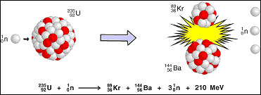
Fusion | 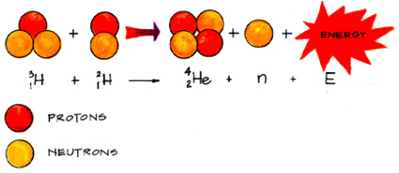
Alpha decay | 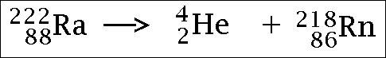
Beta decay | 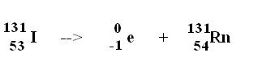
Fission is split
Fussion is union
Both fission and fusion mass is converted to energy
Half life: table N

Redox
Assigning oxidation numbers: FIMHO: free element is zero, ions use what they give you, metals in group one (+1) group 2(+2), Hydrogen is +1 with a non metal and -1 with a metal, oxygen is -2
GERLEO gain electron is reduction lose electrons is oxidation
Electrons before the arrow is reduction and after the arrow is oxidation

Voltaic Cell(Battery or Electrochemical)  An ox and a big red cat: anode oxidation cathode reduction and bigger  Anode is higher on table J  Electrons flow from anode to cathode  Spontaneous  A chemical reaction makes electrical energy  Electrons flow through the wire  Ions flow through the salt bridge | Electroplating(Plating)  An ox and a big red cat: anode oxidation cathode reduction and bigger  Anode is positive side of battery  Electrons flow from anode to cathode  Not spontaneous  Electrical Energy is used to make a chemical reaction  Electrons flow through the wire
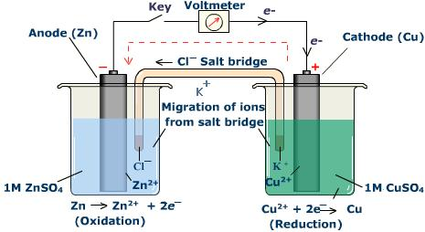 | 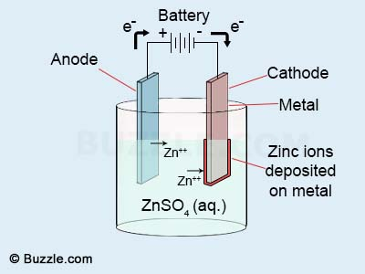
Underlined statements are differences

