Regents Chemistry Review Sheets
Unit 1 Atomic Structure
Vocabulary
Atomic Mass  Atomic Number  Nucleus  Atom  Proton  Neutron  Electron  Nucleon | Ground State  Excited State  Spectral lines  Spectroscope  Valence Electrons  Gold Foil Experiment  Orbitals  Ion | Sub Atomic Particles  AMU  Isotopic Notation  Average Atomic Mass  Isotope

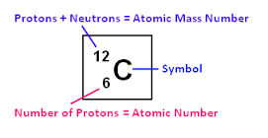
Models of the Atom
Dalton: ___________________________________________________________________
Thompson: ________________________________________________________________
Rutherford:_______________________________________________________________________________________________________________________________________________________________________________________________________________________________________________________________________________________________________________________________
Bohr: __________________________________________________________________________________________________
Modern Theory(Wave Mechanical or Electron Cloud Model): ______________________________
____________________________________________________________________________________________________________________________________________________________________________________________________________________________________
Parts of the Atom
Proton: __________________________________________________________________________
Neutron: ________________________________________________________________________
Electron: _________________________________________________________________________
All about Neutrons
When do neutrons change? What are these particles called? How are they written?

How can we calculate neutrons?

Average Atomic mass calculations:
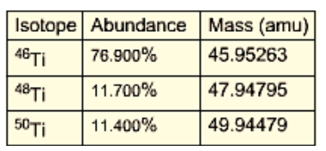

All about electrons
When do electrons change? What are these particles called? How are they written?

What are valence electrons?

Why are valence electrons important?

Where are electrons found on the periodic table?

What are energy levels?

How are spectral lines produced?
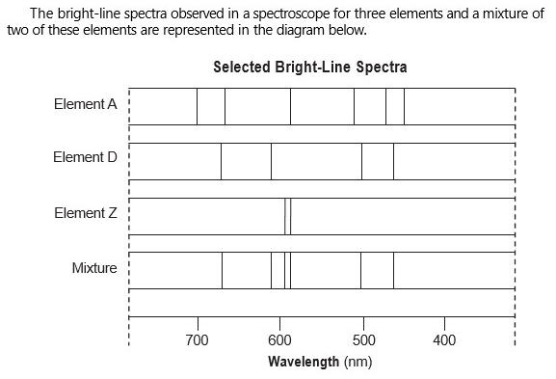
Lewis Dot diagrams for atoms and ions
ATOMS | IONS
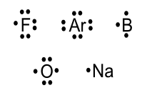 | 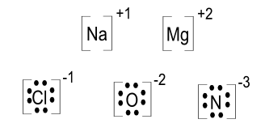
How many dots are drawn? | Why are metals different from nonmetals?

